**TERM PROJECT 2 |** *Exploring the relationship between suicides rates and the GDP per capita as well as the unemployment rate among countries*

Data Engineering 1: SQL and Different Shapes of Data

MSc in Business Analytics 2021

Central European University

**Team Manila**

Haaris Cheema

Muhammad Talha Zahid

Peter Endes-Nagy

Sabina Umarova

**Overview**

**Analysis questions**

* What is the relationship between suicide rates and GDP per capita among countries?
* What is the relationship between suicide rates and unemployment rates among countries?

**Data Sources**

* World Health Organization
* World Bank API

**Indicators Considered**

* WHO Suicide rates
* Population - WB API ID: *SP.POP.TOTL*
* GDP per capita - WB API ID: *NY.GDP.PCAP.CD*
* Unemployment rate - WB API ID: *UEM.TOTL.ZS*

**Data Collection**

1. Suicide rates

World Health Organization database was used to collect data of suicide rates among countries between 2000 and 2019 years. The dataset on suicide rates contains the information on number of suicide rates per 100,000 people for a specific region, country, gender and age group. Data obtained from WHO was transformed into .sql format using Freeware Software in order to allow project to be easily reproduced on any computer without being sabotaged by secure-file-priv issues in MySQL. Unnecessary columns were dropped, variables renamed in a meaningful name. Further data cleaning process was executed in KNIME. For the EER Diagram please refer below:

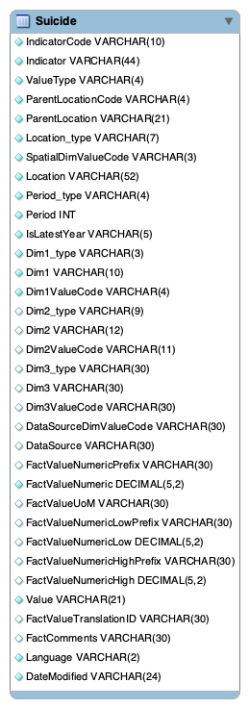

1. World development indicators

Population, unemployment rates and GDP per capita for each country between 2000 and 2019 years were obtained from the World Bank database using World Bank API. Firstly we obtained the structure of query string and figured out how to send request to API using [datahelpdesk.worldbank.org](https://datahelpdesk.worldbank.org/knowledgebase/articles/898581-api-basic-call-structures). We requested all three indicators together for the required period in JSON format. Further JSON files were transformed into data tables in KNIME. For the breakdown of World Bank API request please refer below:

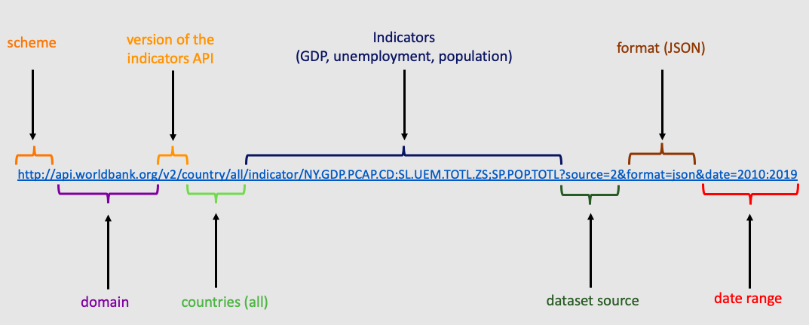

We used Postman in order to check the validity of the request. For the Postman result please refer below:

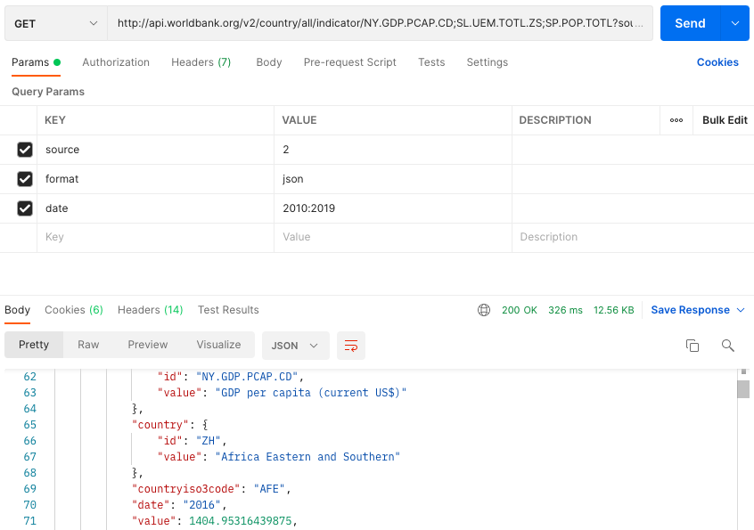

**Data Workflow**

1. List of countries

Firstly, we decided to use R script to obtain the list of all countries. Using WDI package in R we obtained the list of countries and excluded aggregated groups of countries such as European Union, Arab World, East Asia and others. For the nodes used in KNIME workflow to load list of countries using R please refer below:

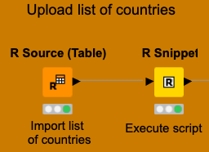

1. API

Further we wrote the URL for World Bank API using String Manipulation node, which is join("http://api.worldbank.org/v2/country/",$knime.in.code$,"/indicator/NY.GDP.PCAP.CD;SL.UEM.TOTL.ZS;SP.POP.TOTL?source=2&format=json&date=2010:2019").

The URLs for each country were added in new column, we send a get request, extracted values of indicators using JSON Path and converted JSON format file into table. We filtered out unnecessary columns so we have only Country Name, Country Code and data values. For that part of KNIME workflow please refer below:

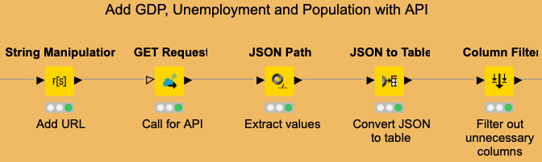

The table was resulted in wide format, so for the next step, we transformed it into long format using R Script. A necessary step for joining with suicide data since the latter is in long format. For that part of KNIME workflow please refer below:

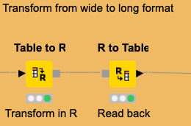

1. Suicide database

Using MySQL Connector node in KNIME we loaded the suicide database. DB Query Reader allowed us to execute SQL query and data was resulted as a data table in KNIME. For that part of KNIME workflow please refer below:

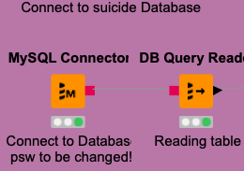

1. Join and clean data

Suicide and WDI data were joined with inner join by using year and country. The resulting table was subject to further cleaning:

* We dropped every row where suicide rate was missing. We also considered zero as missing value. Node used: Rule-based Row Filter.
* In many cases where the suicide rate estimates were exact values, the lower and upper bound estimates were missing. We replaced the missing values with the exact values so the analysis can use both lower both upper bound estimates. Node used: Rule Engine.
* For the age group variable there was no data by age groups before 2019, therefore we filtered for total only. Node used: Rule Engine.
* To make data better-organized we transformed suicide rates as well as the GDP per capita and the unemployment rate to log format. This was done primarily because our subsequent analysis would include regressions and we would want to use a model which explains the greatest variation in our dependent variable (number of suicides). Node used: Math Formula.
* Filters were also added to set the year in which the user wants to analyze the relationships as well as the gender category in which the analysis can be done. For this report, all the analysis will be done on the gender category ‘both sexes’ and the year ‘2019’. Node used: Row filter
* To find the individual correlations of GDP per capita and unemployment rate with the suicide rate, we filtered out the missing values of only the relevant variable for that correlation to preserve the number of data points that we have.

For that part of KNIME workflow please refer below:

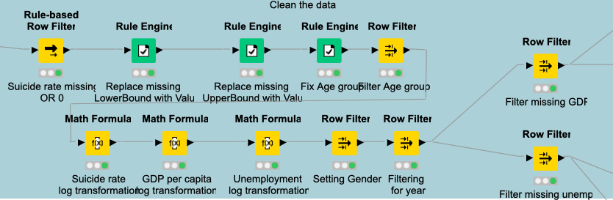

1. Analytics

Upon filtering out the missing values, we used the group-by node to select the relevant columns on which the correlations will be calculated, and the regressions will be performed. We obtained linear regressions and correlations for suicide and GDP relation and suicide and unemployment relation separately. For that part of KNIME workflow please refer below:

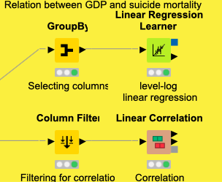 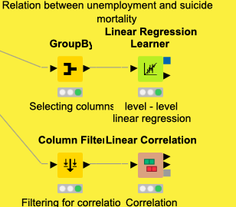

**Results of analysis**

1. Impact of GDP per capita on the number of suicides (per 100,000 population)

Correlation:

We formed a correlation matrix for the GDP per capita, its log value, the suicide rates (Actual Value) and its log value. The results are summarized below.

The output indicates that there is a positive correlation between the number of suicides and the GDP per capita as well as the log of the GDP per capita. The magnitude of the correlation though is weak in both the cases.

Linear Regression:

We also ran a linear regression where we regressed the number of suicides on log_GDP as this model had a higher value for the correlation coefficient.

|  |  |  |  |  |
| --- | --- | --- | --- | --- |
| **Variable** | **Coefficient** | **Standard Error** | **t - value** | **p - value** |
| log_GDP | 0.79 | 0.42 | 1.85 | 0.067 |
| Intercept | 2.70 | 3.77 | 0.72 | 0.475 |

The regression output indicates that the log_GDP is a statistically insignificant variable in explaining the variation in the number of suicides if we test at a 5% level of significance. The scatterplot with the regression line shows the positive correlation between the two variables. However, due to the low strength of the correlation, there is not much variation in the number of suicides in a country as the GDP per capita increases.

1. Impact of unemployment rate on the number of suicides (per 100,000 population)

Correlation:

Like the previous case, a correlation matrix was formed between the unemployment rate, the suicide rates and their respective log values.

The output in this case indicates a positive correlation between the unemployment rate as well its log with the actual number of suicides in a country. The correlation is stronger in the case of the of the level-level correlation.

Linear Regression:

As the previous output indicated a stronger correlation in the case of a level-level model, we therefore ran the linear regression on the same model. The regression output is shown below.

|  |  |  |  |  |
| --- | --- | --- | --- | --- |
| **Variable** | **Coefficient** | **Standard Error** | **t - value** | **p - value** |
| Unemployment | 0.31 | 0.11 | 2.79 | 0.006 |
| Intercept | 7.19 | 0.96 | 7.46 | 3.73E-12 |

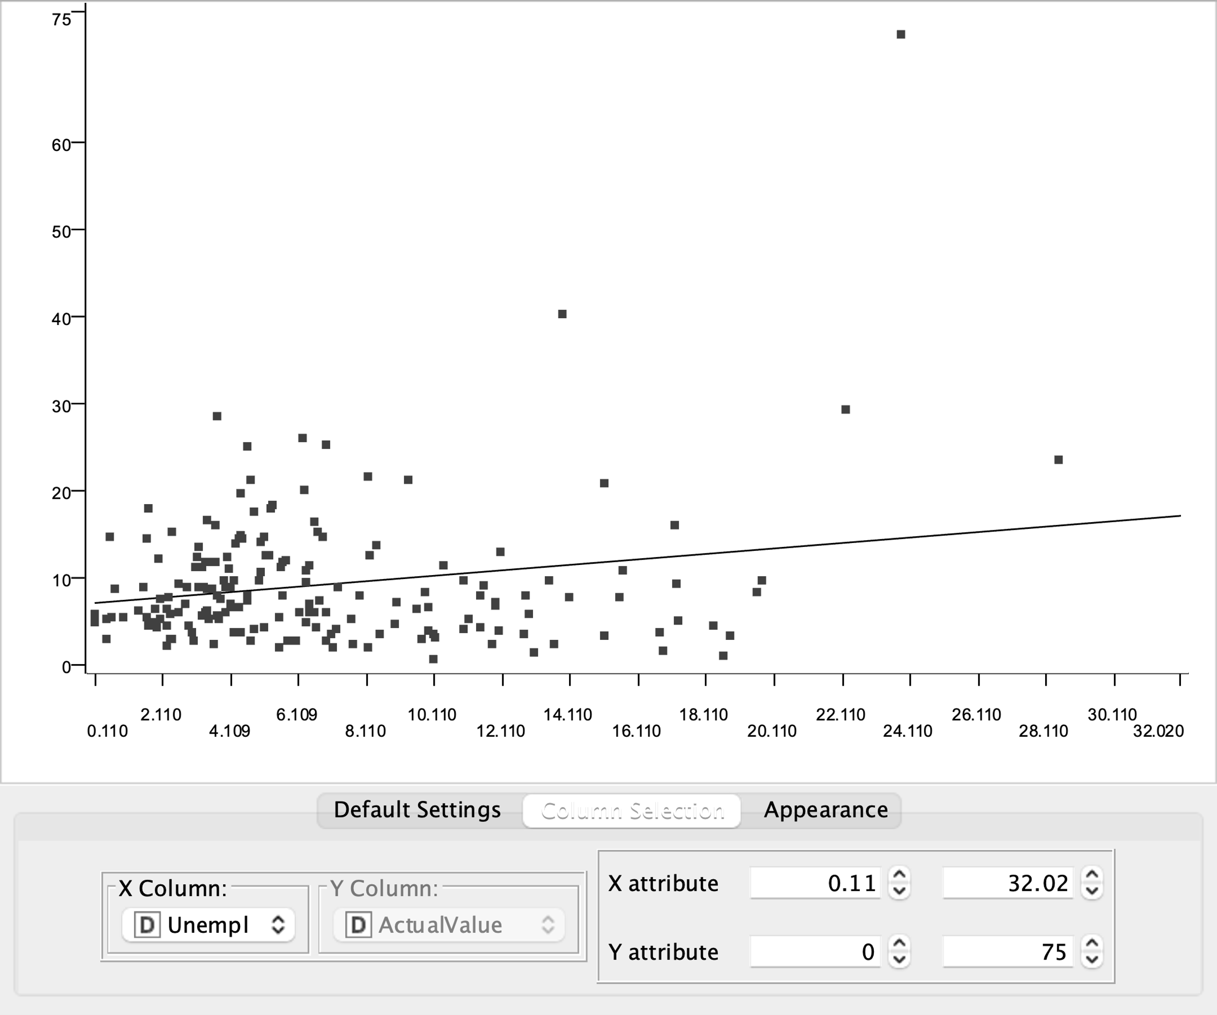

The regression output indicates the unemployment is a statistically significant variable in explaining the variation in the number of suicides when tested at a level of significance of 5%. The regression line also reflects the positive correlation between the two variables. As the unemployment rate increases, we see a gradual rise in the number of suicides (per 100,000 population) in a country.

**Conclusion**

To conclude the project, we analyzed the relationship between suicide rates and GDP per capita as well as unemployment. We used R, MySql and World Bank API to build a database and get data set. We used KNIME to document workflow. We found out positive correlation between suicide rates and unemployment rates and its statistically significant at 5%. We also found out that positive correlation between suicide rates and GDP per capita is statistically insignificant at 5%.

**Who did what?**

* Haaris Cheema – Knime Workflow, Analytics, Documentation, Presentation
* Muhammad Talha Zahid - MySQL, Documentation
* Peter Endes-Nagy - Knime Workflow, Analytics, Documentation, Presentation
* Sabina Umarova – API, Postman, Knime Workflow, Documentation, Presentation